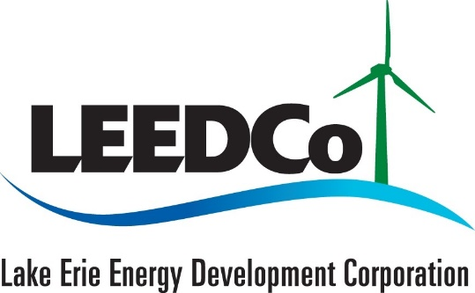

December 8, 2023

Dear Icebreaker Supporters,

We wanted to share with you an important update regarding Icebreaker Wind. Attached, you'll find a press release announcing a change in status for the project. Despite our collective efforts and the unwavering support from incredible partners like you, Icebreaker Wind has encountered numerous challenges and unexpected delays.

After careful consideration, we believe that the most responsible decision, given the circumstances, is to temporarily pause the project. We want to express our immense gratitude for the invaluable collaboration we've shared over the years. Your support brought us incredibly close to our goal.

Challenges that we have faced, including those we overcame, have made the project financially untenable in the immediate future. However, please know the LEEDCo board is actively exploring various avenues that might pave the way for the project to progress at a later stage.

Greg Nemet, a respected energy policy expert at the University of Wisconsin-Madison recently highlighted the challenges facing offshore wind projects on the Great Lakes. He acknowledged LEEDCo's forward-thinking approach by stating, "They were really ahead of their time. It’s high risk, but just because it’s high risk doesn’t mean it’s a bad idea… You can learn from success, but you can also learn from failure."

We are not ready to concede, and we strongly agree that our efforts were not in vain. Our extensive research into the environmental sustainability of offshore wind has laid a solid foundation for future projects. Equally important, we've ignited meaningful community conversations about the potential of offshore wind and the crucial role of renewable energy in our future.

Thank you again for your support and partnership. We will continue to keep you updated on any developments regarding Icebreaker Wind.

Sincerely,
Ronn Richard, LEEDCo Board Chair
Will Friedman, LEEDCo Board Member, Port of Cleveland President & CEO

